

Every Conversation Matters

Scope of Work
Submitted To:

< Client Logo/ Name >

Document Control

Revision History

Version Number | Last Update Date | Change Description | Author/Editor Name | Approver Name
1.0 |  | Initial Draft

Approvers
Approver Name | Title | Date Approved

Reviewers

Reviewer Name | Title | Date Reviewed

Client Signoff

Reviewer Name | Title | Date Reviewed

Note for Onboarding Team :-
When onboarding a new customer on WhatsApp, ensure the Handover Recipe flag is set to TRUE while onboarding.

1. Business Objectives Discovered

Key Objectives and Indicators
Description | Client requirement
Business Objective
Business Problem
Use Case Narrative | (Mention the use-case in brief for e.g. deploying a bot on WhatsApp for students with Live Chat with Video Calling integration)
Expected Volumes
Target Audience | - Active Users  - Dormant Users  - Churned Users
KPI’s / Success Criteria for Project

2. Technical Requirements

Overall Requirement
Description | Client requirement
Number of journeys
Primary Entry Point | - User Initiated  - CTWA  - QR Code  - Campaign Journey
Channels | - WA  - Website  - WA Voice | - SMS  - Others | - Instagram  - PSTN Voice
Bot Language
Language Detection Type (Incase of multilingual) | Automatic
No. of APIs/Backend Services to be Integrated into the bot for fetching/pushing the data in/out of the bot | (Please mention the total number of backend services that you want to integrate)
Session Persistence (Duration of conversation context retention) | Default (24 hrs)
Name of the backend systems in scope
Custom Analytics Requirement  (List Down exact data points if Yes) | - Yes  - No
Select all the modules in scope | - Campaign Manager  - Automated Campaigns  - Journey Builder  - AI Admin  - Goals  - Whatsapp Flows  - CTX  - Agent Assist  - Personalize  - Integrations  - Analyzer and Optimizer
Development Timelines ( In Mandays )
Note : Development and Delivery timelines will vary

AI Specifications
Description | Client Readiness/Requirements
Model Name | Ace Premium ( Azure OpenAI Gpt-4o-mini)  ( STT and TTS Models incase of Voice AI )  Note - AI model to be shared after discussing the use case with the AI pod.
Bot type | Agentic
Use-Case Category | FAQ
Bot Complexity | Simple
Type of Training data | - CSV  - Website  - Text  - Others (Please specify ex: SFTP, Gdrive)
Security/ Javascript Scraping Restrictions (Incase of website) | - Yes (Specify if yes)  - No
Training Schedule (Incase of Website)
  Start Date | 30th December 2025
  End Date | 30th December 2025
  Frequency | 1
  Interval | Daily
AI Languages | Refer here
Priority Intents (List down all intents in scope) | Examples -  - Track my order  - Cancel my order  - Reschedule my order
Related Entities (List down all entities in scope) | - Order_ID, Phone_Number  - Order_ID, Cancellation_Reason  - Order_ID, New_Date, Time_Slot
Estimated No. Questions/intents/FAQs to be uploaded in the bot
Response Guardrails (Incase of FAQs)  (How strict/ lenient should the agent be while answering FAQs) | Zero (Pass-through)
Fallback Strategy (Incase of unknown FAQ/ unidentified intent)  (specify fallback logics/data points in case of argent transfer) | 3rd Party Agent Handover
Human Handover Trigger  (In what scenario shall a human agent be introduced in the conversation) | - User Intent (Keyword)  - Bot Failure  - NPS/ Low confidence  - Unidentified Intent
Testing Data :  Questions & Answers shared by customer | Sample File

- Module-wise Configuration Requirements in Bot (Optional)
Description | Client requirement
Whatsapp Flows
  Type | Description
  - Static  - Dynamic | Briefly describe the form elements
Goals | Specify the milestones/ trackers to be captured
Personalize | Specify custom integration in scope / Attributes to be captured in bot
Agent Assist
  Team Setup | - Yes  - No
  Assignment Rules Configuration | - Yes  - No
  Chat Tags | - Yes  - No
  External Assignment Requirement | - Yes  - No
  Transcript API Integration | - Yes  - No
  Agent Co-pilot | - Yes  - No
3rd Party Agent Handover | To be provided by the 3rd party agent tool:  - Receiving user input.  - Send conversation history.  - Transfer to human agent.  - Create a session/ticket.

- Voice Specifications
Description | Client requirement
Dialer | Knowlarity
Voice Cloning ( Add Sample If Yes ) | No
Call Type | Inbound
Voice Samples for Cloning
Channels | - PSTN  - WA Voice
SIP EndPoint (For WA Voice calls termination)
WABA Number to Enable WA Voice
Websocket URL (If Voice calls need to be terminated to third party AI)

- Deployment/Hosting
Description | Presales Findings
Deployment/Hosting | AWS India

- Additional Scope Elements
Description | Client requirement
Dedicated BA and Project Manager | N/A
Dedicated Developer | N/A
Solutions Mode Bot | N/A
3rd party events integration with personalize | N/A

Capacity and Compliance
Description | Client requirement
TPS | Standard 80
Data Retention | 2 Years - Standard
Data Purge Policy | Immediate (Post-Transfer)
Profile Storage Requirements | Up to 2 Million
Security and Privacy Package | No

Channels : Delete in case of no CPaaS in the deal.
Description | Client requirement
Instagram | N/A
3rd Party CPaaS Integration | N/A
Failover | Yes to Agent Assist
Custom Reports | N/A
Billing Formats | Standard

Flow Diagram & Gantt Chart

Sample Script Voice Ai
Sample Gantt Chart

3. Packaging and Inclusions

One time Dev Costs :

Monthly Recurring Costs :

<<insert from calculator output>>

4. Delivery
Stakeholders from Gupshup(if known at the time of this document)
Roles | Responsibilities | Credentials
Sales | Sales will be responsible for daily communication and ensuring business operations continue as usual.
Presales | Pre Sales will be responsible for ensuring the kickoff between Gupshup's development team and the client team, as well as documenting the Statement of Work (SOW) with all requirements. | Ankit Kanwara
Growth  Manager | Will own the SOW and work with customer to define the phases of deployment mapped to KPI’s
BA | The BA/project manager will be responsible for scheduling, planning, and coordinating the implementation.
Development/ Quality Assurance | The development team will work closely with BA and take requirements for developing the chatbot, Quality assurance will ensure that the bot meets the desired standards, is functioning as intended, and is free from bugs and operational issues.
Onboarding & Training | The onboarding and training team will ensure that the client is well-versed in the functionalities and features of the platform, and will also be responsible for facilitating a frictionless onboarding process.
Support | The support team shall always be available for query resolution under the contract terms and will serve as the first point of contact for any issues in maintaining business continuity.
Security & Compliance | Optional
Customer Success | Customer Success will be responsible for providing regular status updates and growth insights, as well as managing day-to-day operations, handling escalations, scheduling cadences, and other related tasks.
Stakeholders (Optional if known)
Roles | Responsibilities | ABC client
SPOC
Finance
Marketing
Operations

5. Project Management
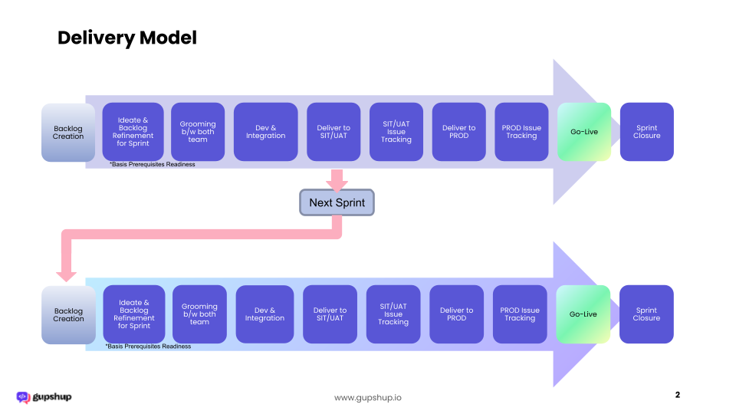

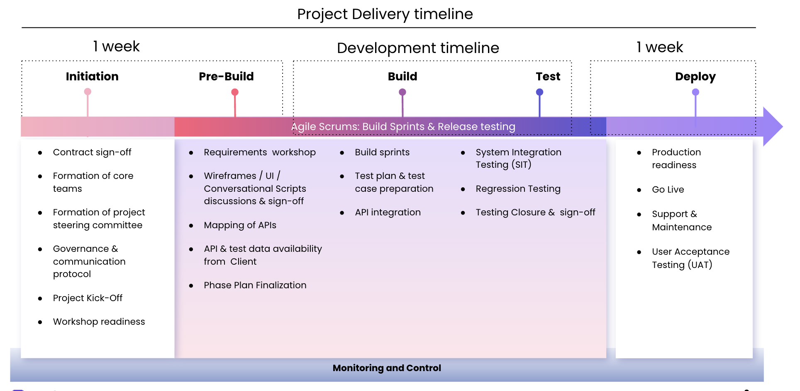

6. Project Governance
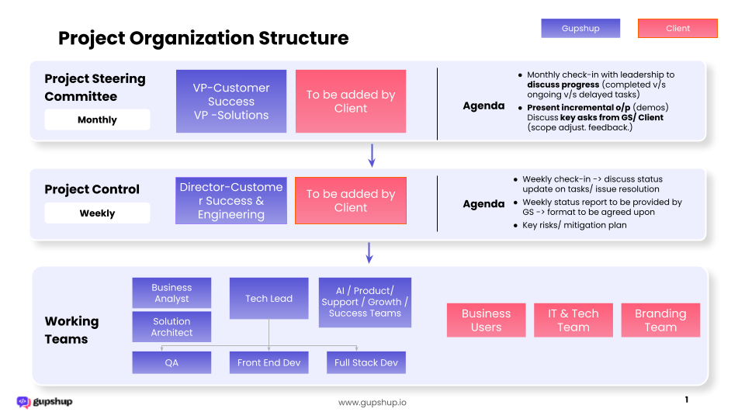

7. Confidentiality and Security
Data Security
- The solution will be hosted in Gupshup’s AWS, India (default)
- The production environment will be hosted in production-grade servers isolated from the development and staging environments using containerization and logical separation.
- All production data transpired in the chat window will be stored in the cloud data center with end to end encryption enabled using AES 256 algorithms.
- PII data will be masked and will not be visible to any user.
- The interactions in transit will be HTTP(s) enabled.
- Developers will have access to Dev & Staging environment only
- The user interface is password protected at all levels.
- Clients have the option to transfer all the data to their data center. Custom integration efforts will be required for this function.
- The data transfer, archiving & purging frequency & mechanism to be defined during design stages and executed during the project.
